Ecommerce Product Analysis

SUMMARY
1. Checking the first 10 imported records

SELECT TOP 10 * FROM products;

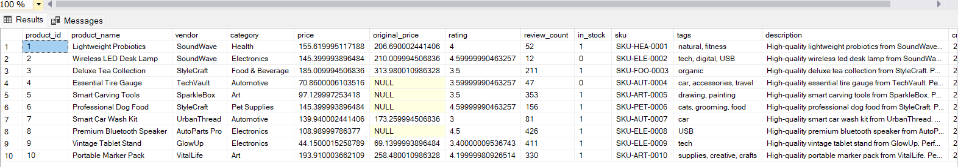

2. Confirming that all 500 products were imported

SELECT
product_id,
COUNT(*) AS DuplicateCount
FROM products
GROUP BY product_id
HAVING COUNT(*) > 1;

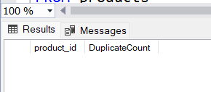

3. Checking whether any SKU appears more than once
SELECT
sku,
COUNT(*) AS DuplicateCount
FROM products
GROUP BY sku
HAVING COUNT(*) > 1;
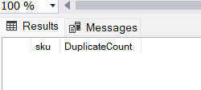
4. Counting missing values in important columns
SELECT
SUM(CASE WHEN product_id IS NULL THEN 1 ELSE 0 END)
AS MissingProductIDs,

SUM(CASE WHEN product_name IS NULL THEN 1 ELSE 0 END)
AS MissingProductNames,

SUM(CASE WHEN price IS NULL THEN 1 ELSE 0 END)
AS MissingPrices,

SUM(CASE WHEN rating IS NULL THEN 1 ELSE 0 END)
AS MissingRatings,

SUM(CASE WHEN original_price IS NULL THEN 1 ELSE 0 END)
AS MissingOriginalPrices
FROM products;
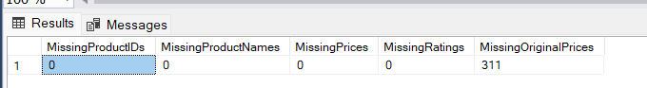

5. Checking for invalid price, rating, review and discount values
SELECT
SUM(CASE WHEN price <= 0 THEN 1 ELSE 0 END)
AS InvalidPrices,

SUM(CASE WHEN rating NOT BETWEEN 1 AND 5 THEN 1 ELSE 0 END)
AS InvalidRatings,

SUM(CASE WHEN review_count < 0 THEN 1 ELSE 0 END)
AS InvalidReviewCounts,

SUM(CASE WHEN discount_percentage < 0 THEN 1 ELSE 0 END)
AS InvalidDiscounts
FROM products;

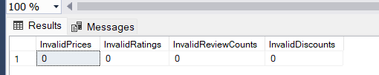

Product Analysis

Question 1 - Find the total number of products, categories and vendors.

SELECT
COUNT(*) AS TotalProducts,
COUNT(DISTINCT category) AS TotalCategories,
COUNT(DISTINCT vendor) AS TotalVendors
FROM products;
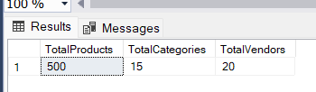

Question 2. Calculate the average product price, average product rating and total number of reviews.

SELECT
ROUND(AVG(price), 2) AS AverageProductPrice,
ROUND(AVG(rating), 2) AS AverageProductRating,
SUM(review_count) AS TotalReviews
FROM products;
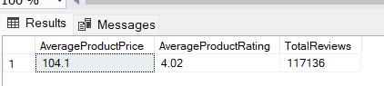

Question 3 - Count the number of in-stock and out-of-stock products.

SELECT
stock_status,
COUNT(*) AS ProductCount
FROM products
GROUP BY stock_status
ORDER BY ProductCount DESC;

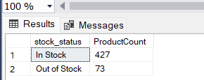

Question 4 - Find the number of products available in each category.

SELECT
category,
COUNT(*) AS ProductCount
FROM products
GROUP BY category
ORDER BY ProductCount DESC;

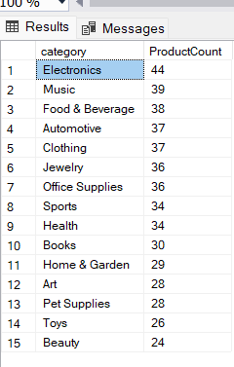

Question 5 - Calculate the average price and average rating for each product category.

SELECT
category,
COUNT(*) AS ProductCount,
ROUND(AVG(price), 2) AS AveragePrice,
ROUND(AVG(rating), 2) AS AverageRating
FROM products
GROUP BY category
ORDER BY AveragePrice DESC;

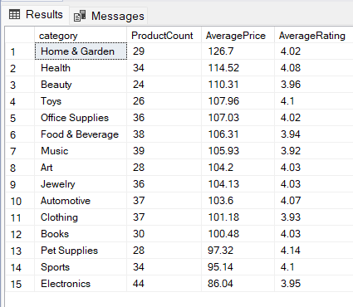

Question 6 - Find the five most expensive products.

SELECT TOP 5
product_id,
product_name,
vendor,
category,
price,
rating
FROM products
ORDER BY price DESC;
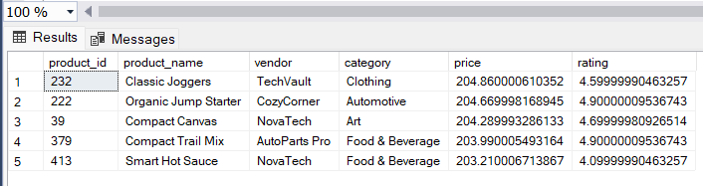

Question 7 - Find the five products with the highest discount percentages.

SELECT TOP 5
product_id,
product_name,
vendor,
category,
price,
original_price,
discount_amount,
discount_percentage
FROM products
WHERE is_discounted = 1
ORDER BY discount_percentage DESC;

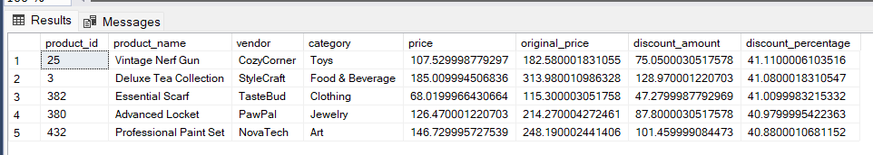

Question 8 - Calculate the number of discounted and non-discounted products.

SELECT
CASE
WHEN is_discounted = 1 THEN 'Discounted'
ELSE 'Not Discounted'
END AS DiscountStatus,

COUNT(*) AS ProductCount

FROM dbo.products

GROUP BY
CASE
WHEN is_discounted = 1 THEN 'Discounted'
ELSE 'Not Discounted'
END

ORDER BY ProductCount DESC;

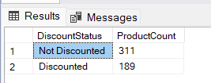
Question 9 - Calculate the average discount percentage for each product category.

SELECT
category,
COUNT(*) AS DiscountedProductCount,
ROUND(
AVG(discount_percentage),
2
) AS AverageDiscountPercentage
FROM dbo.products
WHERE is_discounted = 1
GROUP BY category
ORDER BY AverageDiscountPercentage DESC;

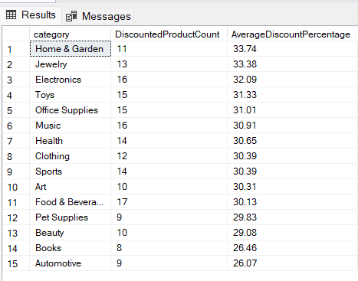

Question 10 - Find all products priced above the overall average product price.

SELECT
product_id,
product_name,
vendor,
category,
price,
rating
FROM dbo.products
WHERE price > (
SELECT AVG(price)
FROM dbo.products
)
ORDER BY price DESC;
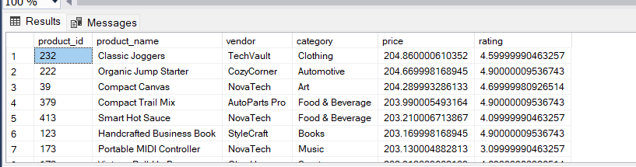

Question 11 - Find categories whose average product price is higher than the overall average product price.

SELECT
category,
COUNT(*) AS ProductCount,
ROUND(AVG(price), 2) AS CategoryAveragePrice
FROM dbo.products
GROUP BY category
HAVING AVG(price) > (
SELECT AVG(price)
FROM dbo.products)
ORDER BY CategoryAveragePrice DESC;

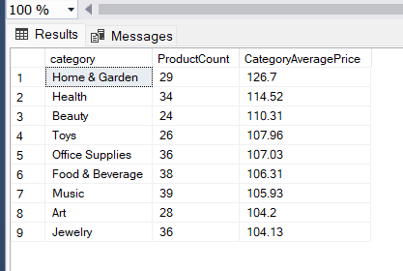

Question 12 - Find the ten products with the highest number of customer reviews.

SELECT TOP 10
product_id,
product_name,
vendor,
category,
price,
rating,
review_count
FROM dbo.products
ORDER BY review_count DESC;

